**Classification Assignment**

A requirement from the Hospital, Management asked us to create a predictive model which will predict the Chronic Kidney Disease (CKD) based on the several parameters. The Client has provided the dataset of the same.

1. Identify your problem statement

Machine Learning---supervised learning—classification.

1. Tell basic info about the dataset (Total number of rows, columns)

399rows, 28columns

1. Mention the pre-processing method if you’re doing any (like converting string to number – nominal data)

Her we have using the On hot encoding methods for converting string to number – nominal data)

1. Develop a good model with good evaluation metric. You can use any machine learning algorithm; you can create many models. Finally, you have to come up with final model.

All the research values of each algorithm should be documented.

(You can make tabulation or screenshot of the results.)

**Logistic Regression Classification**

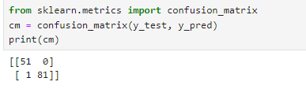

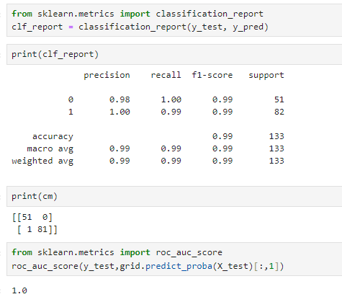

**KNN**

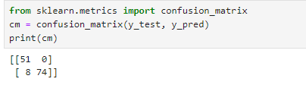

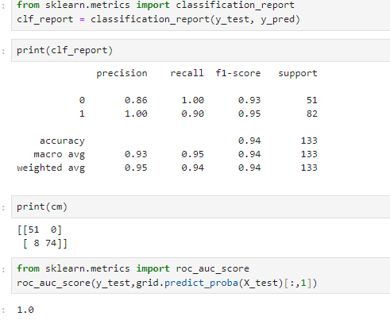

**SVM**

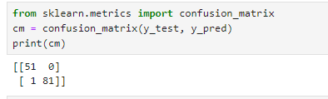

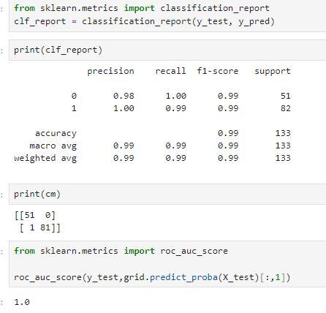

**Decision tree**

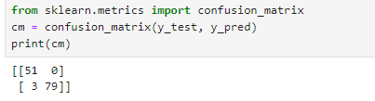

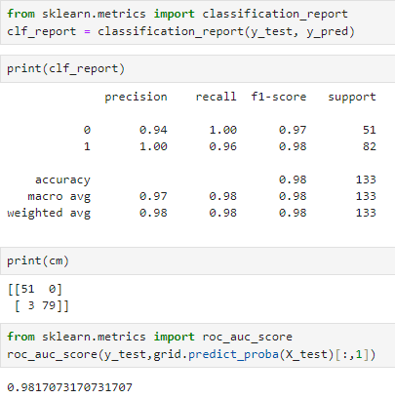

**Random forest**

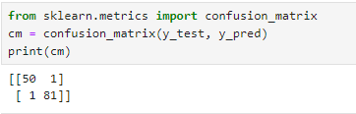

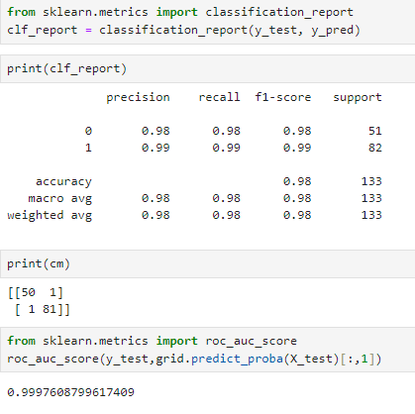

**Multinomial NB**

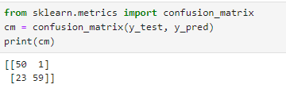

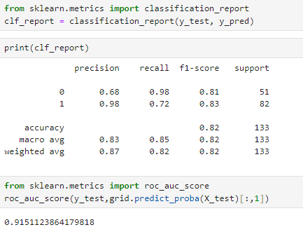

**Complement NB**

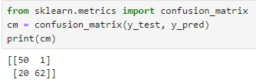

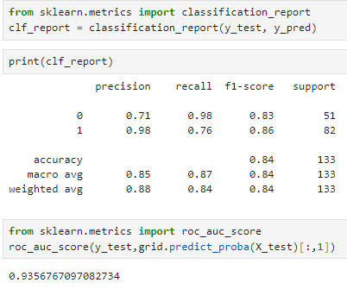

**Categorical NB**

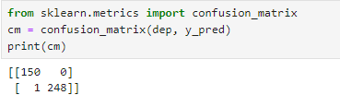

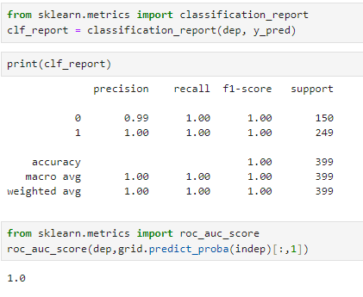

**Gaussian NB**

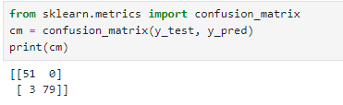

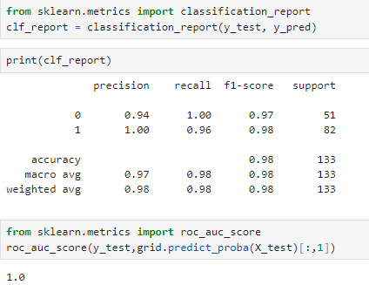

**Bernoullis NB**

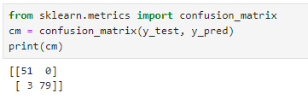

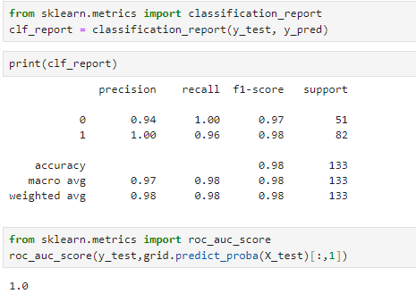

5) Mention your final model, justify why u have chosen the same.

We have obtained accuracy metrics for both Logistic Regression and SVM classification models.

Her with I have saving the modules for Logistic Regression and I have done the deployment file.

Hyper parameter= Best parameters found: {'penalty': 'l2', 'solver': 'lbfgs'}.